
Report of Market Dynamics and Opportunities
CodeX Market Penetration Strategy and Consumer Insights

April 27, 2024
Farhana TAj
Marketing Data Analyst
Contents
Report of Market Dynamics and Opportunities 0
Overview Of Company 2
Objectives of the Project 2
Tools Used: 2
Data Cleaning Strategy: 2
Key Finding: 2
Demographic Analysis 4
Consumer Preference 5
Competition Analysis: 6
Marketing Channels and Brand Awareness: 7
Brand Penetration 8
Purchase Behavior: 9
Product Development: 10
Suggestions for CodeX 11
Improvements 11
Ideal Price 11
Marketing Campaigns 11
Brand Ambassador 11
Target Audience 11
Conclusion: 11

Overview Of Company
German beverage business “CodeX” is attempting to establish itself in the Indian market. They recently introduced its energy drink in 10 Indian cities. They conducted a survey in those 10 cities, and 10,000 people responded.

Objectives of the Project:
- To prepare the dataset for analysis by cleaning it and then processing it.
- To acquire insightful information from many categories to fully comprehend how the market thinks.
- To create clear and compelling visualizations that highlight the most important insights for the Chief Marketing Officer of CodeX to understand.
- To provide ideas and advice that will help the organization establish a growth strategy that will be successful.

Tools Used:
- Microsoft Excel
- Microsoft Word
- Power BI

Data Cleaning Strategy:
- If Heard_before = 'No', then Tried_before = ‘No'
- If Heard_before = 'No', then Brand_perception = 'Neutral'
- If Tried_before = 'No', then Taste_experience = 'Null'

Key Finding:
- Around 60% of consumers are MALE followed by Female and Non-Binary.
- Age Group 19-30 prefers energy drinks the most. This Age Group has nearly 50% consumers among all others.
- Almost 42 % of consumers get to know about energy drinks through Online Ads.
- Caffeine is the most preferred ingredient in energy drinks which is around 39%. Vitamins, Sugar & Guarana comes next in line.
- 39.8% of respondents prefer Compact & Portable Cans as they are light weight & easy to hold.
- Cola Coca acquires 1/4th of the energy drinks market followed by Bepsi & Gangster. Codex comes 5th in the market ranking.
- 26.5% of the respondents rely on Brand Reputation which is a major factor over preference of other brands. Other reasons include Taste/flavor preference, Availability etc.
- Online ads are the most reachable marketing channel across all age groups. It is around 40.2%.
- Supermarkets are the most preferred location to purchase energy drinks. Almost 45% respondents prefer supermarkets.
- Around 40 % of consumers say that limited edition packaging influence purchase decisions.
- If the price of the energy drink is between 50-99, people tend to purchase more.

Demographic Analysis
The data suggests that males, particularly those in the 18-29 age group, are the predominant consumers of energy drinks. To effectively market to the youth demographic, online advertising strategies, especially through social media, are recommended due to their higher engagement and direct reach.
Gender-Wise Preference

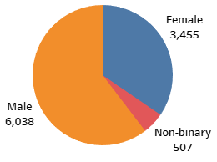

Age-Wise Preference
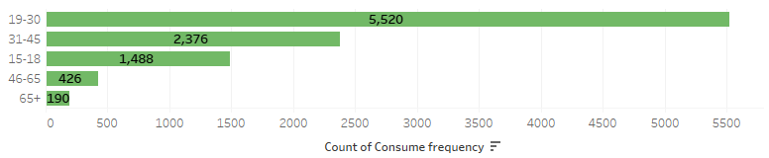

Age/ Marketing Channels
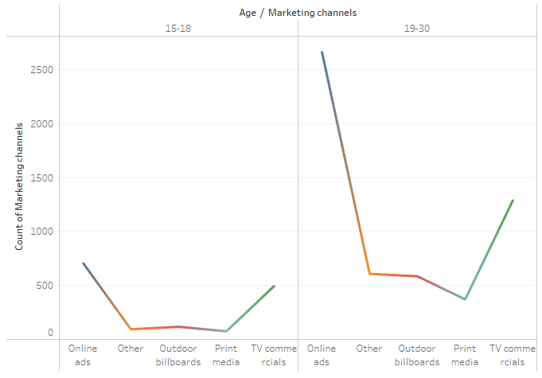

Consumer Preference
The findings indicate that caffeine is the key ingredient that consumers expect in energy drinks, while compact and portable cans are the preferred packaging choice. These preferences highlight the importance of functionality and convenience in the energy drink market.
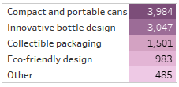
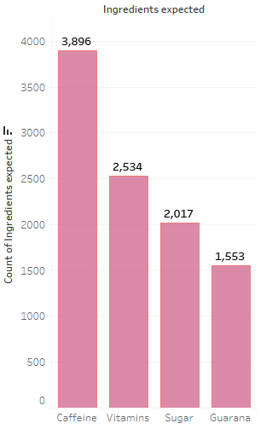
Packaging Preference
Ingredient Preference

Competition Analysis:
Coca-Cola’s leadership in the market can be attributed to its strong brand reputation, which is a result of its global reach, innovative approaches, focus on health-conscious products, effective marketing strategies, and superior taste. These factors contribute to the brand’s preference over competitors, including our own brand. Understanding these elements can guide strategic decisions to enhance our competitive position in the market.
Current Market Leader
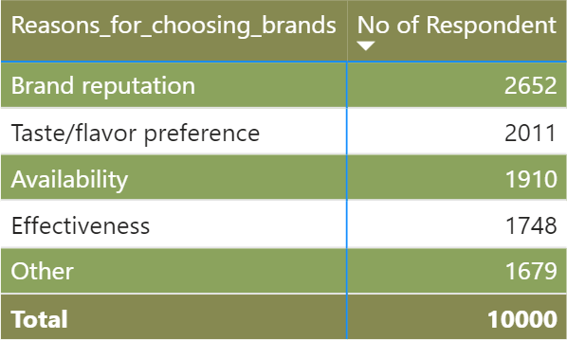
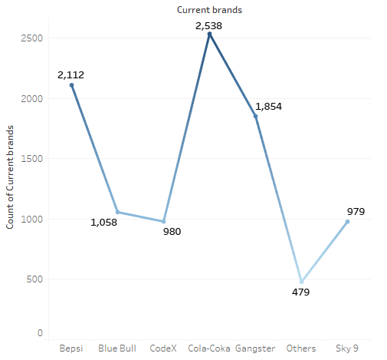
Consumer Preference

Marketing Channels and Brand Awareness:
Online ads are a highly effective marketing channel for reaching more customers due to their wide reach and the ability to target specific audiences. Different marketing strategies and channels have their unique strengths, and their effectiveness depends on aligning them with the company’s marketing goals and the preferences of the target audience. By leveraging these channels strategically, businesses can significantly enhance their brand awareness and customer reach.

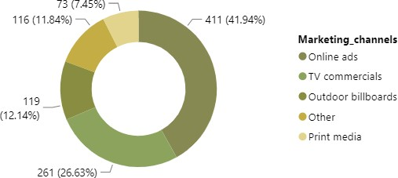
Effective Marketing Channel

Brand Penetration:
The neutral public perception of our brand indicates an opportunity to build a stronger brand identity and customer relationship. By focusing on the identified cities with low brand penetration and employing targeted strategies, we can improve our market presence and consumer engagement. It is crucial to monitor the impact of these strategies through ongoing market research and adapt our approach as needed to achieve the desired brand growth.
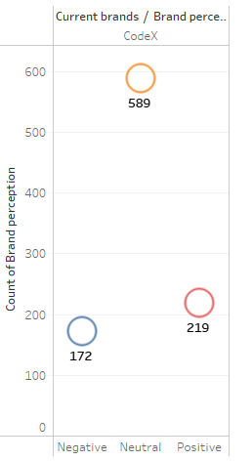
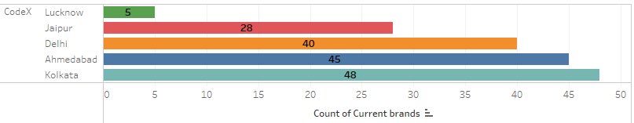
Brand Rating
Bottom 5 cities to focus on

Purchase Behavior:
Supermarkets are the preferred venue for purchasing energy drinks, with sports and exercise being the primary situations for consumption. Marketing strategies that focus on distinctive packaging and optimal pricing can effectively influence consumer purchase behavior. Understanding these factors can assist manufacturers and retailers in tailoring their offerings to meet consumer demands and preferences, thereby driving sales and customer satisfaction.
Purchase Location
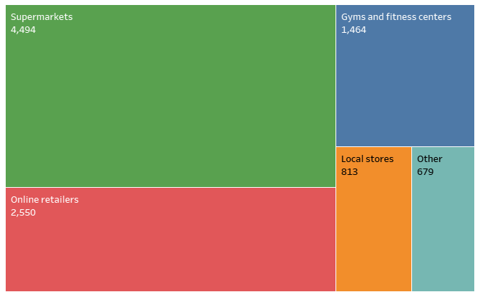

Purchase Behavior
Purchase Situation
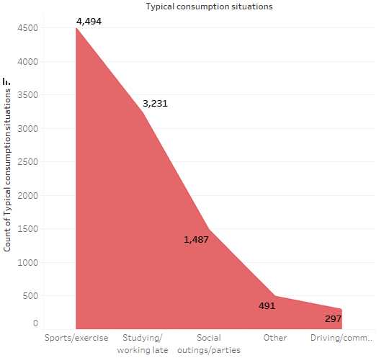

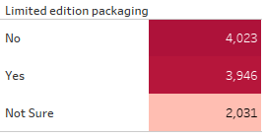

Product Development:
Considering the overwhelming evidence supporting the importance of branding in product development, it is recommended that our company places a heightened focus on branding strategies. By doing so, we can ensure that our products not only meet the functional needs of our customers but also resonate with them on a deeper, more meaningful level.

Reason For Choosing Brand

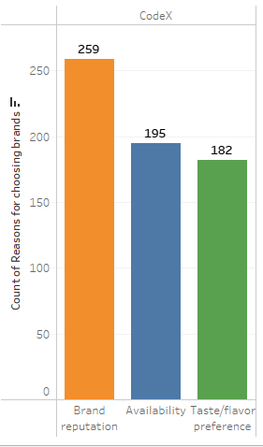

Suggestions for CodeX:

Improvements
    - Introduce a range of new, fresh flavors.
    - Design simple yet attractive packaging.
    - Reduce the sugar content in products.

Ideal Price
    - Set prices between Rs 50-99 to attract customers.
    - Ensure prices mirror consumer expectations and perceptions.
    - Focus on increasing gross sales rather than immediate net profits.

Marketing Campaigns
- Offer products in bundle deals.
- Launch seasonal promotions and limited-edition products.
- Collaborate with social media influencers for wider reach.

Brand Ambassador
- Engage a popular sports personality with a strong public appeal.
- Partner with a musician who has a significant fan base.

Target Audience
  - Focus on young individuals who frequent cafes.
  - Target athletes, fitness enthusiasts, and instructors.
  - Market to nutritionists and health-conscious consumers.

Conclusion:
In essence, it is imperative for CodeX to leverage these insights to tailor their offerings and marketing strategies to the unique dynamics of the Indian market. By focusing on the suggested improvements, embracing the ideal price point, and engaging in creative marketing campaigns, CodeX can enhance its market share and establish a strong brand reputation. Collaborations with social media influencers and the appointment of popular figures as brand ambassadors can further amplify their reach and resonance with the target audience.

